Methodology
Consumer Prices Index – 2017

Table of Contents
Background of the Survey | 3
Target Population and Survey Sample Frame | 4
Survey Sample | 5
Stages of the Survey | 6
Main Documents of the Survey | 8
Survey Staff | 9
Fieldwork Phase | 10
Data Processing Phase | 11
Main Definitions | 13
Improvement Plans | 13

First: Background of the Survey
1.1 Introduction
Indices is used in the statistical applications in the field of economic studies, as they can identify the economic conditions of different countries, through analysis studies of indices , as well as it helps to predict what may happen to different variables in the future.
In addition, the index measures the developments on prices, volumes, and values of different kinds of statistics, for example: the prices index measures prices changes from time to time. The production index measures the change in production of the industrial sector for different periods. Also, index for foreign trade measures the movement of imports and exports both in terms of size or quantity from time to time. Indices are no longer limited to economists in their analysis, but a means in the hands of people who are interested in social, administrative, and other specialized studies for carrying out future comparisons, analysis, and prospects. Thus, the index is an indicator used in statistical analysis to measure changes in any phenomenon over time that can be expressed digitally.
The indices of consumer prices, are calculated in the DSC based on to the standards and concepts prepared by international and national authorities. In order to:
- Comparability between the other emirates
- Comparability between the other countries
1.2 Objectives of the Consumer Prices Index:
Consumer prices Index (CPI) is one of the important indices, which is keen to be issued by all the statistical centers, so the objectives of CPI can be summarized according to the importance of their use, which they are:
- Consumer prices index is a statistical tools for measuring changes in the prices of consumer goods and services from time to other.
- Consumer prices index is widely used as accurate indicator for measuring trends in inflation and economic recession.
- Consumer prices index is a means for measuring changes in the currency purchasing power.
- Prices index is generally one of the important tools used in preparing national accounts by ridding the national gross income from the impact of prices changes.
Second: Target Population and Survey Sample Frame
2.1 Target Community:
Studying the prices of group of goods and services in consumer prices system, classified according to the Classification of Individual Consumption according to Purpose (COICOP) in order to calculate the index according to the following division:
- Food and beverage.
- Tobacco.
- Clothing and foot wear.
- Housing, water, electricity, gas, and other fuels.
- Furnishings, household equipment and routine household maintenance.
- Health.
- Transport.
- Communication.
- Recreation and culture.
- Education.
- Restaurants and hotels.
- Miscellaneous goods and services.
2.2 Survey Sample Farm:
The survey sample frame is based on sources that are selling consumer goods and services, where the specialists selected the sources that provide the selected consumer basket, taking into consideration permanent availability of those goods and services and the selected sources cover all areas in the Emirate of Dubai.
Third: Survey Sample
3.1 Sampling Units:
It is known that the consumer prices cover a broad group of goods and services, and considering the comprehensive census to collect the prices of those goods and services will be costly and may be impossible. In common practice, the collection usually held on a sample of groups of goods and services from a sample number of sources. In fact, if the selection of these sources done in an appropriate way it will result in better data, because of the use of a qualified and trained limited number of data collectors. In this context there are two different types of samples: the first type, is called the probability samples, This type of sampling are selected randomly, and each unit of the subdivision likely determinant different from zero, and can rely on the results of these samples for circulation to the communities in which they pulled them, and determine the degree of confidence in the results and calculation committed errors. The second type, called a non-probability sampling or Purposive sample, this sampling way do not rely on the principles of probability, the sample are selected based on personal control. Due to the lack of census for sources of consumer goods and services in most cases, and complications of designing probability samples to represent the target community and its error calculation techniques. The practice of many countries depends on the non-probability or purposive sampling for the collection of consumer goods and services prices.
As the Emirate of Dubai constitutes of geographical area, and there is a great similarity in the prices of goods and services from different sources. The Dubai Statistics Center implement probability and Non Probability or purposive samples for the collection of goods and services from the retail, central and services stores, the sample unit was chosen on arbitrary manner or personal control, Ensuring coverage of all types of goods and services included in the consumer basket, on a permanent basis.
The total number of goods and services within consumer basket is 1,980 commodities collected from 238 sources, considering the exact timing of price collection (weekly, monthly, and quarterly).

Fourth: Stages of the Survey
The survey phases included a series of overlapping and integrated operations carried out by the team, depending on the methodology of the governance and management of statistical operations phases to prepare the action plan and timetable for its implementation to ensure completion of the work within the highest quality standards. It included the following:
4.1 Design Phase
This phase included the preparation and review and approval of preliminary statistical form also includes sample design and its methodology, preparation of description variables and the design and adopt the validation, auditing and reviewing rules, as well it include the methodologies of data processing and reports for the statistical systems.
4.2 Building Phase
This phase includes design, preparation and adoption of statistical form, and develop systems for input and calculation of the consumer prices index. As well as, the design and build reports for the statistical systems.

4.3 Field Data collection Phase
This phase includes collection of data from the field and it is considered the most important and largest phase of the survey. As it includes the preparation phase where the frame is define and the sample units selected and known. Moreover, it includes develop field data collection methodology, training programs and coordination with target sources. In addition, it includes the field work that involve collection of data from the field and progression report, verification of filling the form, and numbering the forms and data entry and archive paper forms.
4.4 Data Processing Phase
This phase includes processing of data, which includes the classification and variables coding, implementation of auditing rules, auditing data, adopt raw data, editing missing values, as well it includes linking variable from different sources, weight calculation, calculate results of division and approved pre final database.
4.5 Analysis Phase
This phase includes calculating preliminary results and initial indicator calculation, Auditing overall results, and comparison of pervious statistics, Data Analysis, Review result and its privacy level, Approve final results after revision, coordination with external concerned to approve the final results. Hence, in this phase the general mythology and the approved working methods will be documented.
4.6 Dissemination Phase
In this phase, the dissemination process will start by ensuring the results of all reports and its dissemination liability, coordination with concerned statistician to agree on the dissemination level. In addition, the dissemination level should be defined, reviewed and determined in order to be published on the statistical systems. As well as the electronic publication, Press releases on media, manage the DSC social networking channels, Handle CRM Request and respond to our customers inquiries.
4.7 Evaluation Phase
The final phase of the project is this phase which includes the evaluation of the statistical project with internal and external authorities’ coordination as well develop and approve the improvement plan.
Fifth: Main Documents of the Survey:
The survey documents includes the data collection forms, index calculation program, outputs tables, and display of the results.
5.1 Survey Form:
A simple form was prepared for each source. The form contained the name of the source, commodities number, description, the items description, barcode, and source of origin, unit, and a place for the price to be recorded.
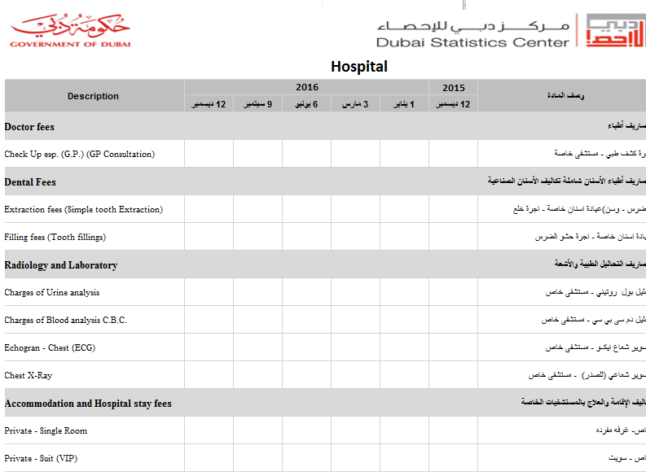
5.2 Data Coding:
Data was coded according to the Classification of Individual Consumption according to Purpose (COICOP) in order to calculate the index according to main divisions level, group level, and class level reaching to item level as the below example.
Example:
Code (COICOP) | Description of division/group/class/commodity/item
01 | Category of food and beverage
01.1 | Food
01.1.1 | Bread, grain, and their products
01.1.1.1 | Rice
01.1.1.1.01 | Indian Basmati Rice

Sixth: Survey Staff
6.1 Functional Structure of Survey Staff:
The survey staff who participated in technical, administrative, and fieldwork was organized as follows:
- Technical Supervisor of the Survey: The roles include preparing all the technical methodologies related to the study “the integrated methodology, auditing methodology, and results methodology.” In addition, he is the only reference for any technical instructions related to questions, concepts, definitions, and variables of the survey form and any other technical aspects related to the form, in addition training surveyors and preparing a detailed report, calculating and analyzing results.
- Surveyor: A total of 7 surveyor the role involve field visit to collect data, ensure that all required data in form is collected and audit it before living the source, then data entry process they should enter the collected data in the system that use for the consumer price index and the initial audit of the collected data.
6.2 Staff Selection and Training:
Since the Surveyor are Department staff, 7 members were selected to work in the survey on different level as supervisor or executive levels according to several bases and pervious experience. A training plan was developed and the staff were trained beginning of the survey and data collection phase. The training includes definition of the survey and its objectives, the data to be collected, and collection mechanism. They were also trained practically on the data entry system.
Seventh: Fieldwork Phase:
7.1 Organizing Fieldwork:
The phase of field preparation and implementation must get the comprehensive care for all details. To ensure the highest possible level of data accuracy and quality, a quality control rules was designed for data collected from the field, through:
- Training the survey staff on fieldwork practically and administratively.
- Providing a series of field and administrative procedures needed to achieve a high level of accuracy, through:
  - Studying reports from the field and responding to inquiries directly.
  - Holding regular meetings with field staff to discuss their opinions about goods and services listed in the consumer basket and their prices in different sources.
  - Continuous monitoring of the field staff performance.
  - Comparisons and matches for prices of goods and services that are randomly selected to test the field staff performance.
- Field Checks of the Frame:
  - Supervisory field checks, including:
    - Sources filed visit.
    - Examination according to the alternative methodology.
    - Examining internal correlation of data.
  - Field checks in the final form while working on the field.
  - Providing records for controlling the movement of forms.
It should be noted that an information database must be used to help examine field data quality, which reduced time and effort on project supervision.
After data is collected from field, it will be edited by the field staff, then data will be entered in designed data entry system to include all goods and services data and sources where the prices are collected from. Then, averages will be calculated on item level.
7.2 Data Collection Method:
Data collection goes through several processes:
- Visiting the source for the first time
- Introducing the survey and its objectives to the person in charge in the source
- the field staff member agrees with him/her on the data collection mechanism preferred (field/telephone/e-mail)
The prices of goods and services are collected on different basis:
- On monthly basis for most of most classes
- On quarterly basis for some of the classes
- On weekly basis for the goods and services with inconstant prices, such as fresh food
The field staff members also review the prices range from different sources and different time periods, and insure the accuracy of some of the prices through field visit, and also get rid of some prices that do not match the logical series of prices movement.
7.3 Field Audit:
During the field visit for data collection, the surveyor insures that all collected data are correspondent to previous prices of goods and services, which are mentioned in the survey form in order to judge the accuracy of data given. After finishing, the collection process before leaving the source, the staff member audits, reviews, verifies all the data collected and stated in the form.
Eighth: Data Processing Phase
8.1 Office Processing:
After data is collected from field, a process of data review is carried out by staff members. Office audits can be summarized through the following:
- Prices represent the desired month.
- Prices are in the required currency.
- Prices are collected from all sources needed.
- Quick review of the rationale of the price recorded.
- Do not make any changes to the goods and services description, unit, prices or any data recorded on the form without informing the survey supervisor.
- Not to change the source without informing survey supervisor.
- Receipt of all data from all sources.
In case of mismatch between two prices, the surveyor goes to field once again to make sure of the accurate price. Then prices of goods and services will be entered on data entry system for desired month and then reviews the entry process.

8.2 Electronic Processing:
Developing an integrated system for the prices work in two phases. The first phase is the data entry system for entering monthly prices and calculates the averages prices (monthly, quarterly, annually) for all goods and services in the basket. While the second phase is the calculation system that produce the consumer price index (monthly, quarterly, annually) for all goods and services divisions.

8.3 Result Dissemination:
Upon completion of the calculation of the indices the results will calculated and produced to be displayed in private tables and graphs, knowing that the process of dissemination of data should take place according to the rules that have been agreed upon the level of confidentiality, considering the specific standards and regulations according to the following points:
- Private controls for confidential data
- Private controls for reduction that is being published
- Private controls for international publishing standards if the statistics is committed to doing internationally
The final results are calculated and produced into two phases, the first phase calculates the average prices for all goods and services (monthly - quarterly - yearly). The second phase is, the average price using the outputs of the first phase for calculating and producing the consumer prices index on (monthly, quarterly, and annually) basis. Hence, the reports are produces in form of tables that are then disseminated in the form of Statistical reports and newsletters and providing those outputs in several ways:
- DSC Website.
- DSC’s Smart System.
- DSC’s Application
- Periodical press releases.
- Dubai Statistics Indicators System.

Ninth: Main Definitions
The definitions and classifications used in this survey are based on the international standards issued by the United Nations and some of its specialized agencies as accepted in DSC.
Data Sources:
Are the establishments where all data of goods and services in each division are collected from, as retail stores (such as cooperative societies, supermarkets, fabrics and clothing shops, Garments, and furniture shops, etc), and services shops (such as restaurants, cafes, hospitals, private schools, doctors, etc), in addition to the residential units for rent.
Consumer Price:
The price paid by the consumer for obtaining a good or service for household needs.
Division:
The group of goods and services on which a consumer spends on for household purposes.
Laspeyres Index:
A mathematical equation developed by Statistician Laspeyres for calculating price index by dividing prices of the year of comparison by the prices of the base year, and base year weights.
Price Index:
The average proportional changes in the prices of a certain goods and services between two time periods.
Base Period:
The time period that is compared to the current period.
Base Period Prices:
The prices of goods and services to which the current prices are compared.
Relative importance:
The ratio of goods and services importance within the consumer basket.

Tenth: Improvement Plans:
- Updating the list of goods and services in the consumer basket.
- Follow on continuous update of the internationally-accredited methodologies and classifications

